

User Manual
Sign in
Step 1. Select menu icon at top right corner of screen
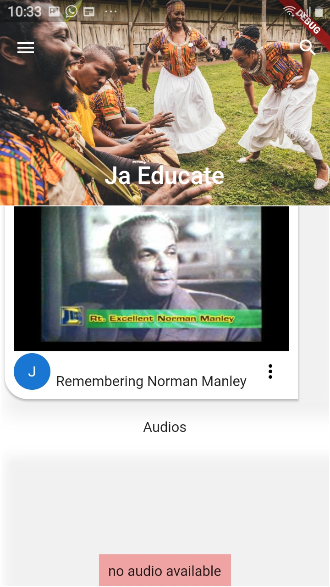

Step 2. Tap on “Sign In” option in the popup menu
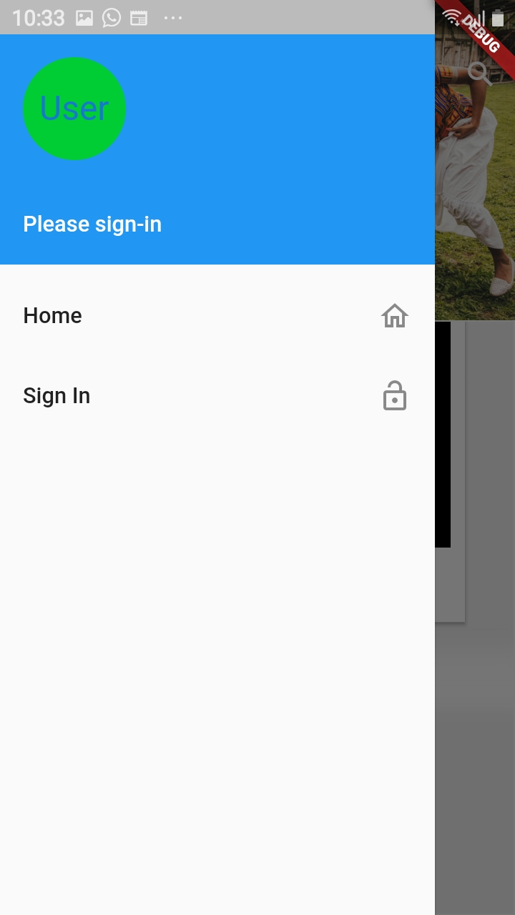

Step 3. On the new page enter your email address and password in appropriate areas.
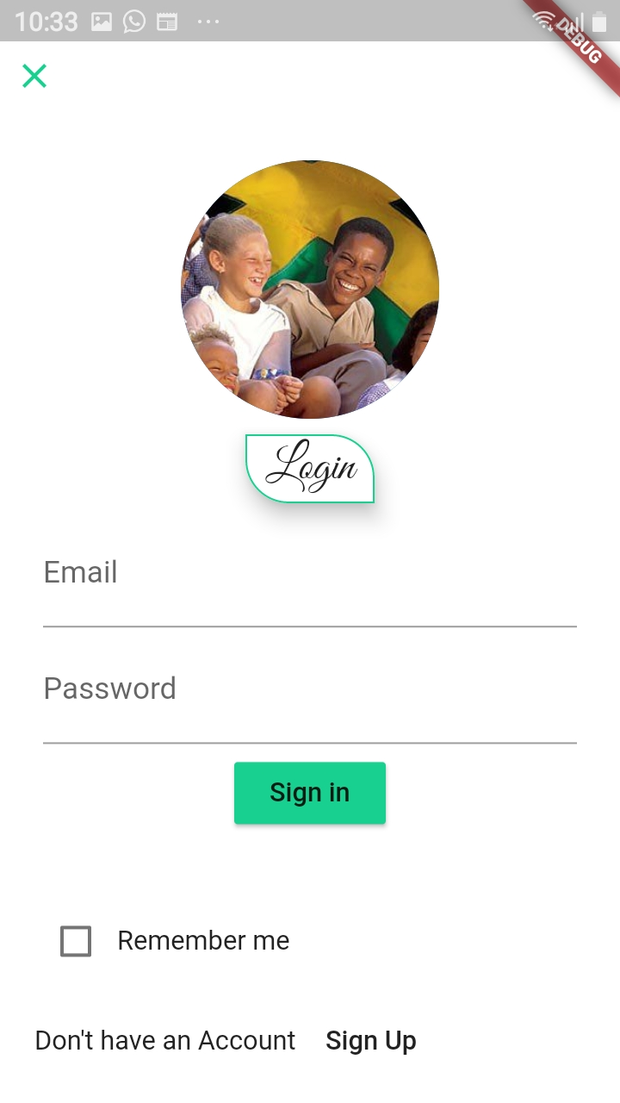

Step 4. Press, “Sign in” button, wait for credential to be verified, if Sign in fails repeat step 3.

Registration
Step 1. Select menu icon at top right corner of screen

Step 2. Tap on “Sign In” option in popup menu

Step 3. Scroll down to bottom of page then select “Sign Up” option

Step 4. On the new page fill all fields with the appropriate and information.
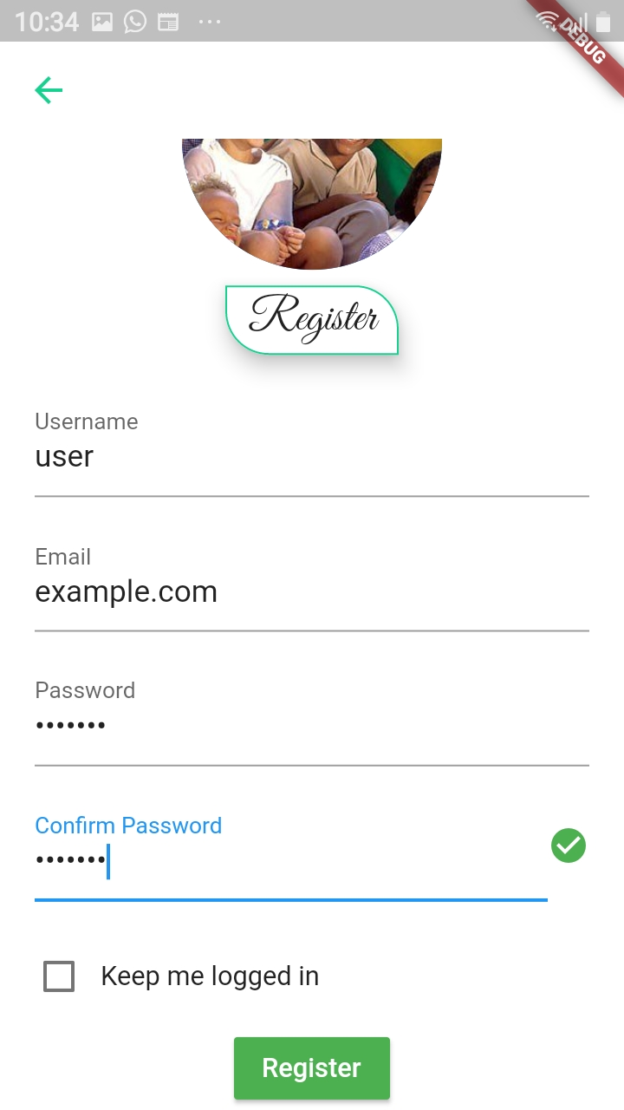

Step 5. Press, “Register” button, wait for information validation, if this fails repeat step 4.

Adding Content
N.B user must have a valid expert user account to perform this task.

Step 1. Sign in to a valid expert user account
- For more information view sign in method.

Step 2. Select menu icon at top right corner of screen

Step 3. Tap on “Add Content” option in popup menu
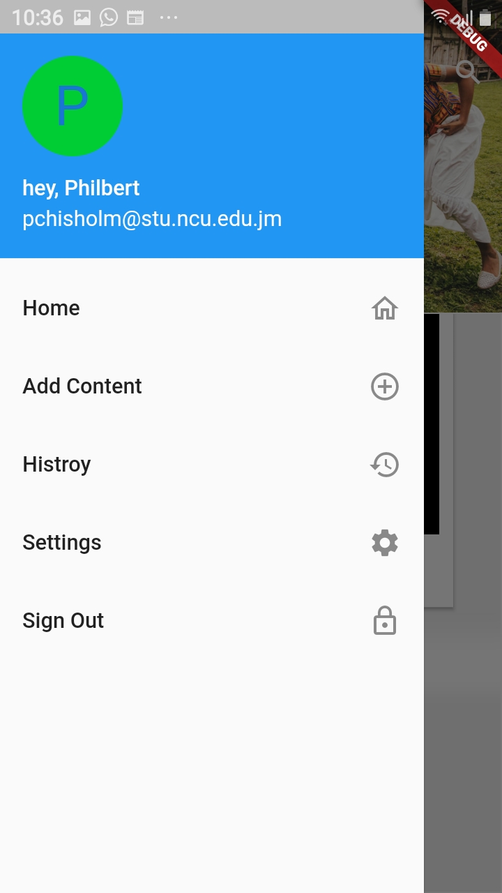

Step 4. On the new page press, “Add Content” button.
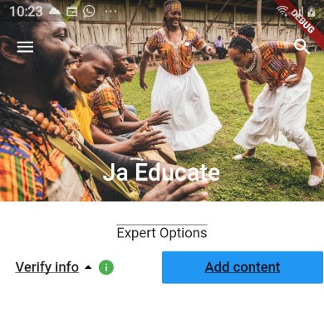

Step 5. On popup form fill each form fill where necessary
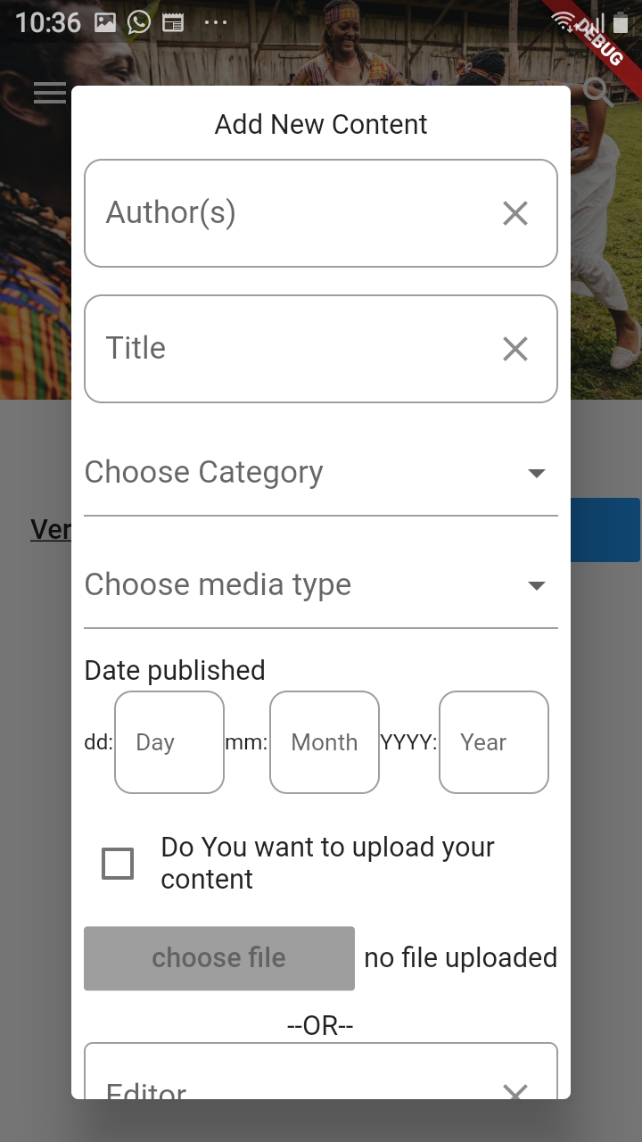

Step 6. Adding document directly from device
- Tap checkbox “Do you want to upload your content”
- Press, “choose fill” button, it should now be activated.
- Select a file from your device.
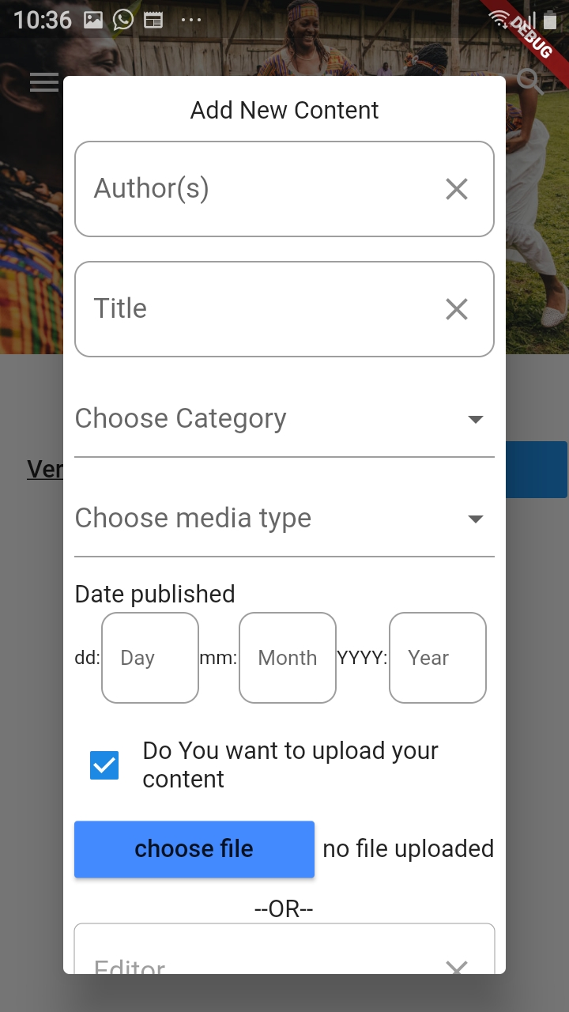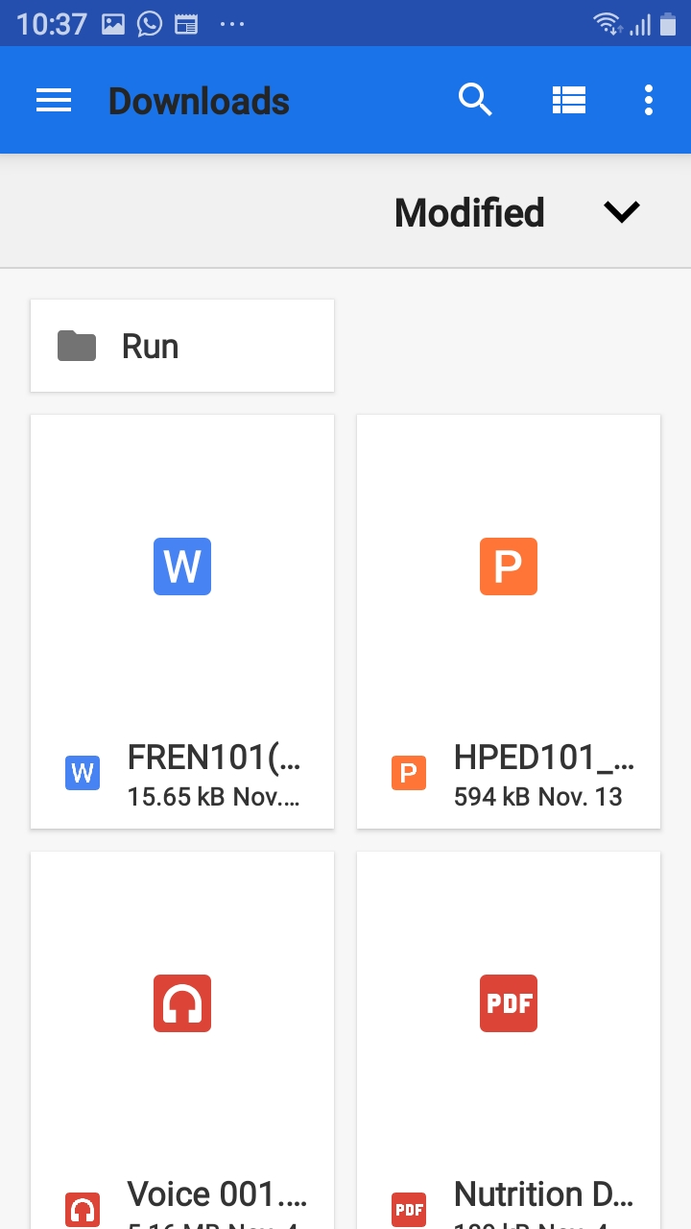

Step 7. Press, “Submit” button to add content, “Reset”, to clear form, “Cancel” to close form

Editing user settings
N.B user must be Signed in to gain access to this option.

Step 1. Sign in to a valid user account.
- For more information view sign in method.

Step 2. Select menu icon at top right corner of screen.

Step 3. Tap on, “Settings” option in the popup menu.

Step 4. On the new page Tap, checkbox “Edit Profile” to allow data change.
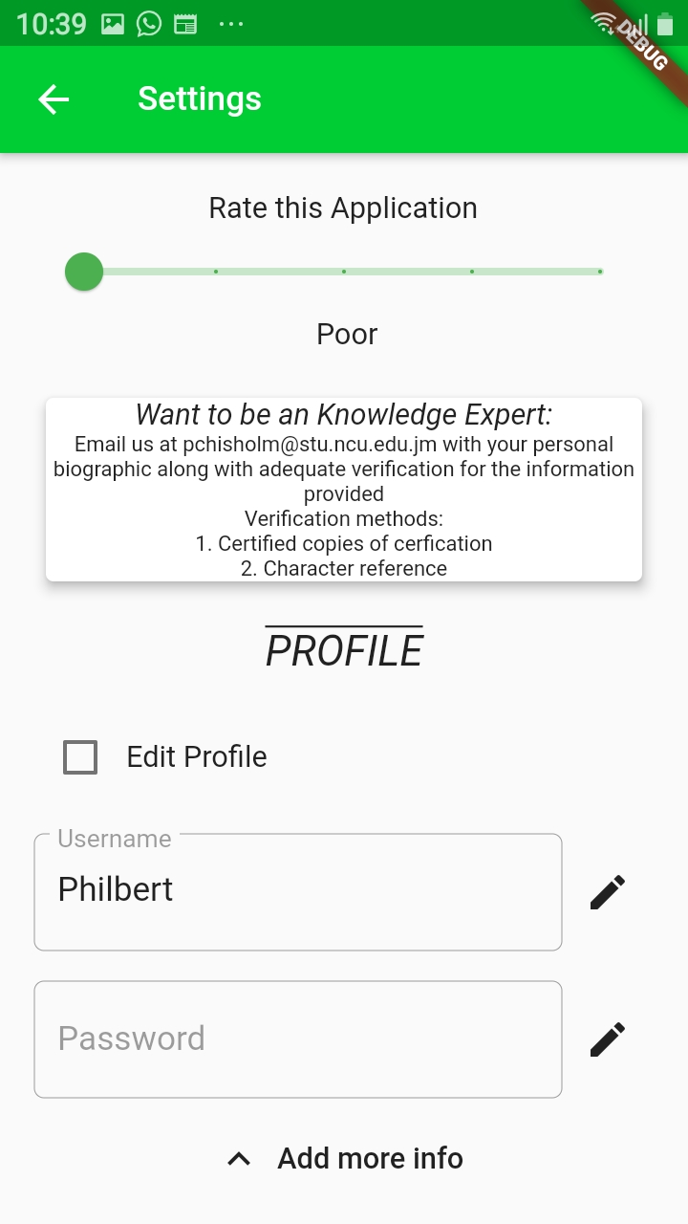

Step 5. Select the field to be changed and make amendments.

Step 6. Tap pencil icon to commit change.

View History
N.B users must be Signed in to gain access to this option.

Step 1. Sign in to a valid user account.
- For more information view sign in method.

Step 2. Select menu icon at top right corner of screen.

Step 3. Tap on, “History” option in the popup menu.
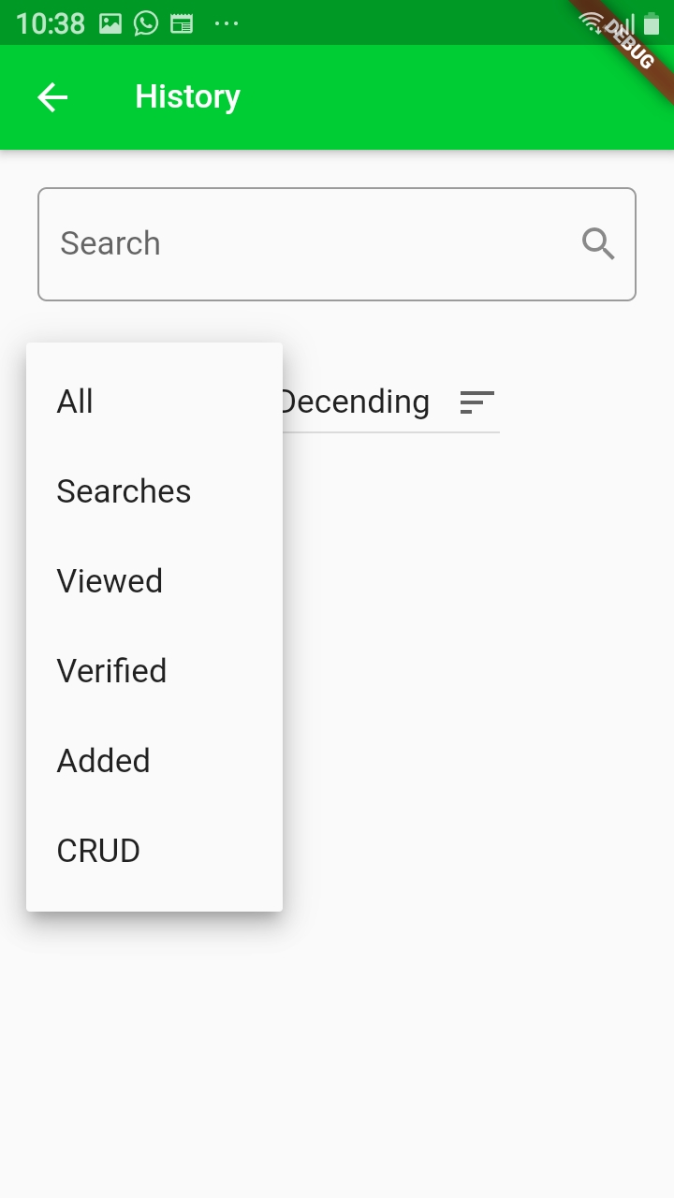

View Content
Option 1:
Step 1. Select menu icon at top right corner of screen.

Step 2. Tap on, “Home” option in the popup menu.

Step 3. Browser content by category by swiping both horizontally and vertically.

Option 2:
Step 1. Tap on, Search icon to the top left of the screen.

Step 2. Enter the search keyword in the search text area to refine displayed content.
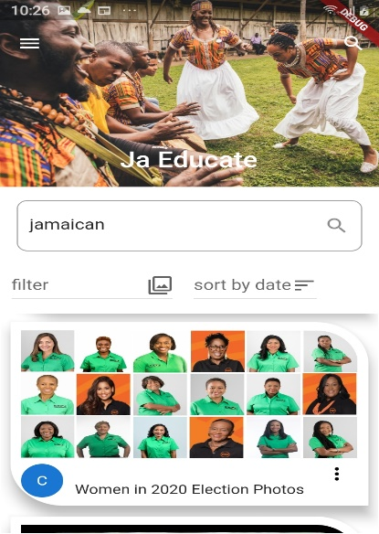

Step 3. Browser content by category by swiping vertically.
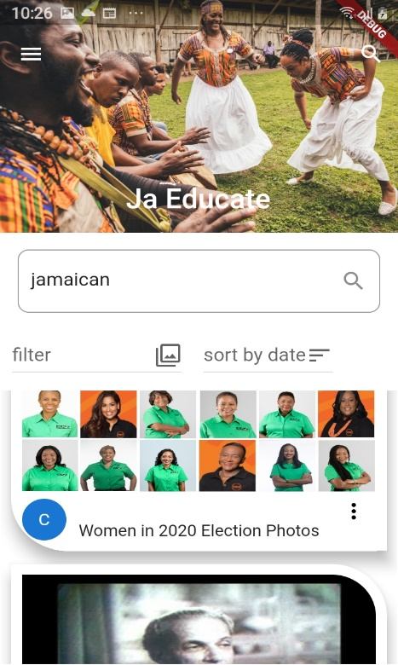

Sign out
Step 1. Select menu icon at top right corner of screen

Step 2. Tap on “Sign out” option in popup menu
Other features

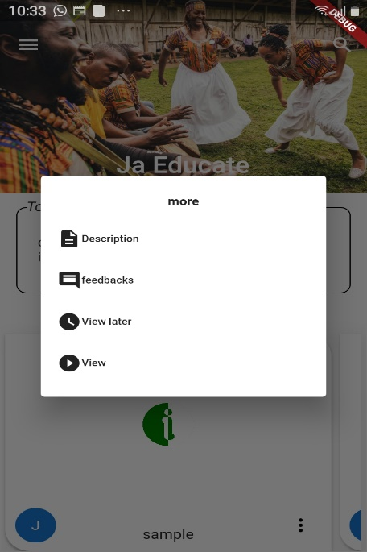
- View content description – view description of the selected content
- Add Feedback – leave feedback/comment on content
- View Late - add to watch later list
- View - display the content

